CSA 1717-ARTIFICIAL INTELLIGENCE
LAB EXPERIMENTS
Abinaya Sri J(192524429)
AIM
To solve the 8-Queens problem using the Backtracking algorithm so that no two queens attack each other on an 8×8 chessboard.
OBJECTIVE
To place eight queens on an 8 × 8 chessboard without conflicts. To understand the working of the Backtracking algorithm for solving constraint satisfaction problems.
ALGORITHM
Step 1: Start with an empty 8 × 8 chessboard.
Step 2: Begin placing the first queen in Row 0.
Step 3: For the current row, check each column one by one.
Step 4: Before placing a queen, verify that:
- No queen is present in the same column.
- No queen is present in the left diagonal.
- No queen is present in the right diagonal.
Step 5: If the position is safe, place the queen.
Step 6: Move to the next row and repeat Steps 3–5.
Step 7: If no safe position is available in a row:
- Remove the previously placed queen (Backtracking).
- Try the next column in the previous row.
Step 8: Continue until all 8 queens are placed successfully.
Step 9: Display the final chessboard.
SOURSE CODE
N = 8

# Create an empty chessboard
board = [[0] * N for _ in range(N)]

# Function to check whether a queen can be placed
def safe(row, col):

# Check same column
for i in range(row):
if board[i][col] == 1:
return False

# Check left diagonal
i = row - 1
j = col - 1
while i >= 0 and j >= 0:
if board[i][j] == 1:
return False
i -= 1
j -= 1

# Check right diagonal
i = row - 1
j = col + 1
while i >= 0 and j < N:
if board[i][j] == 1:
return False
i -= 1
j += 1

return True

# Backtracking function
def queen(row):

# If all queens are placed
if row == N:
return True

# Try every column
for col in range(N):

# Check safe position
if safe(row, col):

# Place queen
board[row][col] = 1

# Move to next row
if queen(row + 1):
return True

# Backtrack
board[row][col] = 0

return False

# Start placing queens
queen(0)

# Print solution
print("Solution Board:\n")

for row in board:
print(row)
FLOW CHART
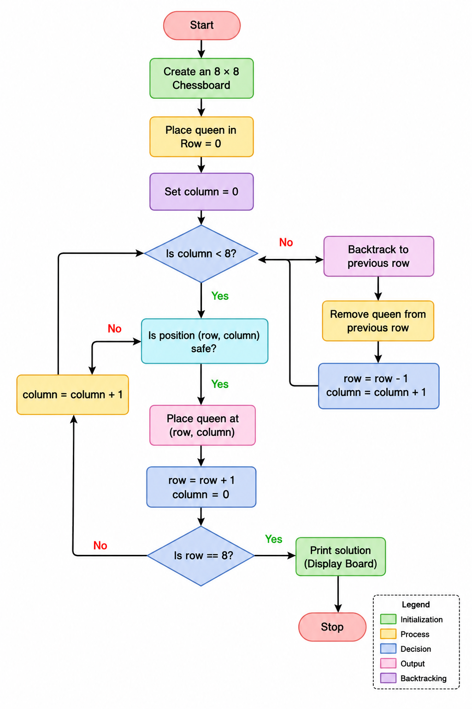

OUTPUT
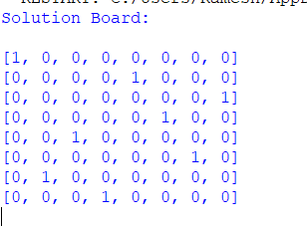
RESULT
The 8-Queens Problem was successfully solved using the Backtracking Algorithm. The program placed all eight queens on the chessboard such that no two queens attacked each other.

